MR.jit Computer Vision Toolbox
Welcome to the weird and wonderful world of Computer Vision and object tracking! Since you downloaded this document I assume that you also downloaded the MR.jit Toolbox for Max/MSP/Jitter. If not, grab it here: http://www.martin-ritter.com/PatchesAbstractions/MRjitToolbox.zip
This should include all necessary files, libraries, abstractions and externals needed. If for some reason some pieces of the puzzle should be missing and you get error messages after you have installed everything properly, here are the websites to look for them:
Anything containing “MR” is an abstraction, patcher, bpatcher, external, etc… that was written by me. If it is not included in the download it is most likely on oversight on my part. If it is not on my website (www.martin-ritter.com/software.html), please e-mail me and I will get you up and running ASAP: martin@martin-ritter.com
Cv.jit externals are part of the Open Computer Vision library, ported by Jean-Marc Pelletier into Max/MSP/Jitter. His objects can be found here: http://jmpelletier.com/cvjit/
Other than that only standard Max6 objects are used and you should be ready to go.
Installation
There are two ways to make Max6 see all the needed files.

- Move all files into the Max6 folder:
HD/Application/Max6/Cycling74/jitter-externals

Here, create a new folder called “3rdParty” if you wish and put all associated files there.

- Put all files in your general working Max6 folder and point Max6’s search path to it. For that start Max6, click Options in the file menu, then click “File Preferences…”. Add a new path and point it towards the directory with all the files. Make sure you enable the “Subfolders” toggle so Max can see all files in all embedded folders!!

That should do it. Restart Max6 to make sure the search path gets updated properly. You are ready to go!!!
General Overview 3
Detailed bpatcher Overview 6
MR.jit.absDiff 7
MR.jit.bgSub 8
MR.jit.binary 9
MR.jit.blob 11
MR.jit.bounds 12
MR.jit.boundsComplex 13
MR.jit.center 14
MR.jit.close 15
MR.jit.conv 16
MR.jit.delay 18
MR.jit.face 19
MR.jit.faceOpt 21
MR.jit.keying 23
MR.jit.matrixSize 25
MR.jit.motionComplex 26
MR.jit.subMatrix 27
MR.jit.videoRec 28
MR.jit.trackIt 29
Instrument Tracking: 31
Piano Tracking 31
Trombone Tracking 32
Upcoming Modules: 33
MR.jit.camShift 33
MR.jit.flow 33

General Overview

Most bpatchers are the same size, and when possible have the same general layout. All of them have internal messaging structures so that each can be controlled via remote messages created somewhere within the logical structure of your patch and then passed on to each module. Generally, there are little or no inlets to set parameters, so making sure that you understand the messaging system is crucial (see the detailed descriptions below).
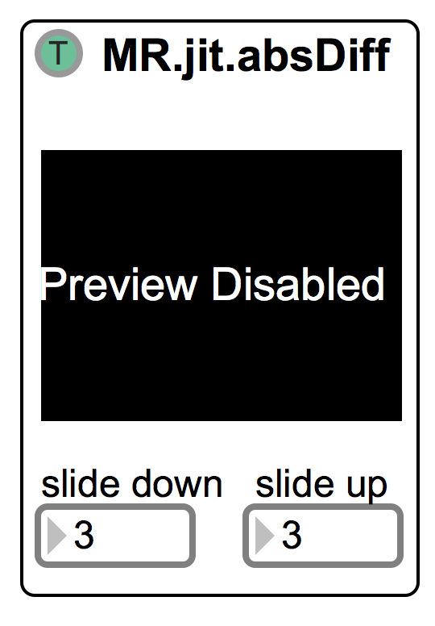
This is a typical bpatcher and its layout. The name appears at the top (a number appended to the name indicates an instance number; More about that below). The toggle on the left is by default green and set to “T”.

“T” = through
“L” = luma

By default each unit will use the incoming matrix as is. Most units however will only work on gray scale images. When toggled to “L”, the incoming matrix will be converted from argb (alpha, red, green, blue) to gray scale.

[Side note:
You might ask why the toggle is set to “T” by default and not “L”, since many analysis object will need gray scale. Simple, once the matrix is converted to gray scale and you pass it on to another object, you need to have “T” selected or the object tries to convert a gray scale matrix to another gray scale matrix in which case Max6 will be very angry with you!!!]

Some objects will have control parameters on the top as well as on the bottom; in the example above only two floating values can be set at the bottom of the bpatcher. All objects have a preview window embedded that by default is turned off. By clicking into the window (or by toggling a switch for a select few bpatchers) or by sending it a message, the preview can be enabled. It is suggested that you keep preview off once your system is up and running whenever possible and only have those on that might need constant checking and manual input, this will safe a LOT of CPU power!!

Remote Messaging

All bpatchers have the ability to receive external messages to set the state of each element of the object. There are several ways messages can be send in Max, two will briefly be explained.

- Use of the “message” object to send remote messages:
The Max “message” object has the ability to send messages to anywhere within the program if the box is properly formatted. The below message object will send a message to the above “MR.jit.absDiff” object and set the “slide down” number box to 17:
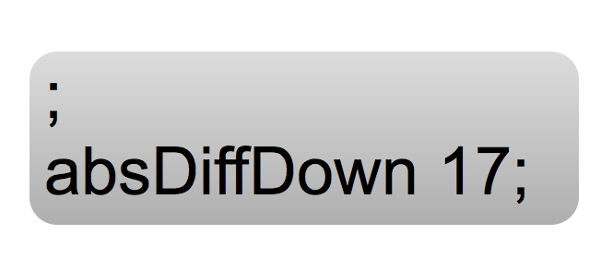
Note the semi-colon at the beginning of the message!! This indicates to Max that this is a message to be sent! Next we have the name of the object that is going to receive the message, here “absDiffDown” (inside the bpatcher there is a “receive” object with that name connected to the number box), and last the message to be sent. The message can be anything (ints, floats, symbols and lists) but lists will be used very rarely. Use the “$1” convention to be able to change the value of the message interactively. Use semi-colons to separate multiple messages.

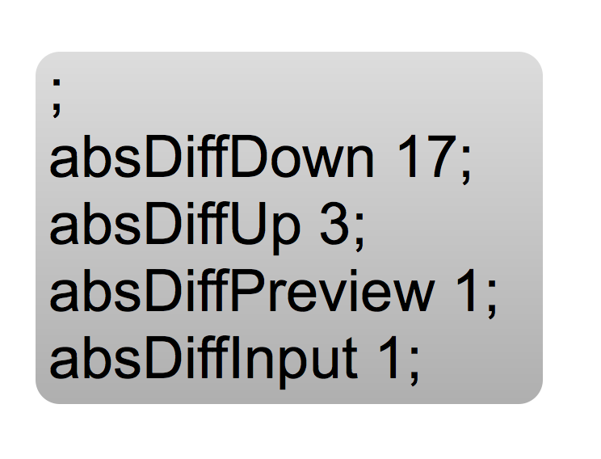

- Use of the “send” object to send remote messages:
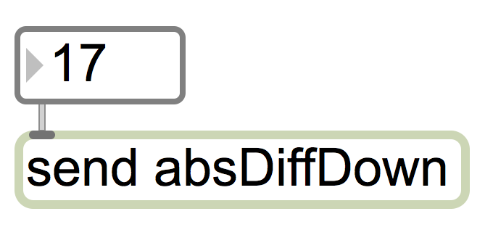

Here the “send” object is used to achieve the same end result as with the above technique.
A separate custom abstraction was created to deal with multiple instances of objects (see below for more information on instances).
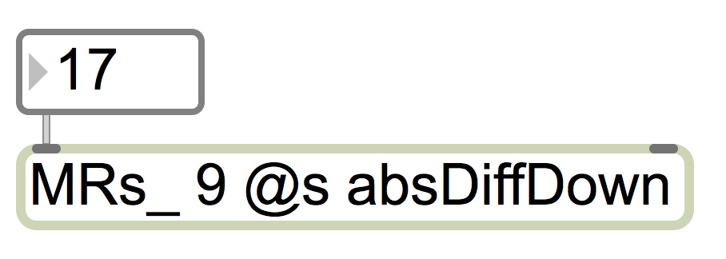

This abstraction formats everything internally and forwards the input to the intended receiver. “MRs_” signifies that it is a “sending” object, which will append the first argument after an underscore. The “@s” tells the object that the following string is intended as the name of the “send” object. Here the number “9” will be added to the symbol “absDiffDown” resulting in “absDiffDown_9”. Any incoming message (int, float, symbol, list) will be forwarded to that receiver if it exists (see the help file for MRs_ for more info and further examples).

In the above example (MR.jit.absDiff), external messages can be used to enable the preview window by sending a message to “absDiffPreview 1” or disabled by sending “absDiffPreview 0”. Similarly, “absDiffDown 6”, and “absDiffUp 2” will set the number boxes to these values.

If multiple instances of the same bpatcher are needed, the bpatcher’s first argument in the inspector should be set to a unique number.
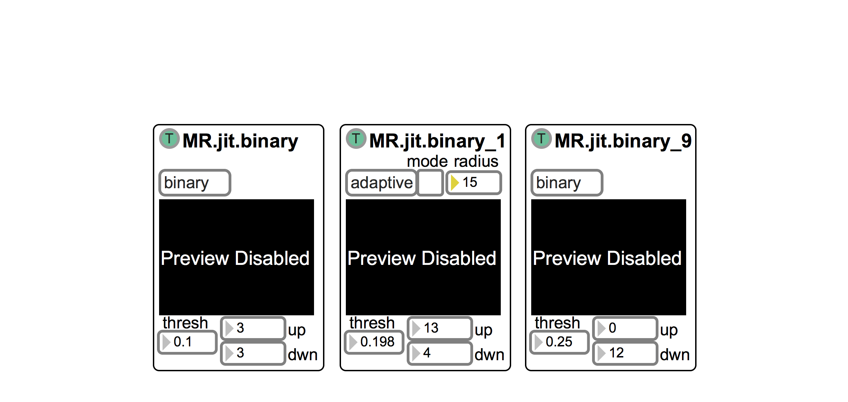
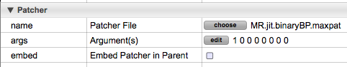
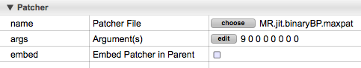
Here, three unique instances of the same module are used. The first one has no argument (could also be set to “0”, however the 0 will be omitted in the name). The second one has been given a “1” and the third one a “9” as their unique identifiers.

These identifiers have to be added to any message so it can be routed properly to the intended instance. For example, the message “binaryPreview 1” will only turn on the preview window of the first module. To access the other modules the instance number needs to be appended to the message: “binaryPreview_1 1” and “binaryPreview_9 1” respectively (see the use of “message” objects and “MRs_” above).

Detailed bpatcher Overview

The following section will describe each bpatcher in detail in terms of functionality, inputs and outputs, as well as remote messaging capabilities.

MR.jit.absDiff

Compute the absolute difference of successive frames of video with optional frame smoothing. Can be done on either an argb or gray scale matrix.
Result: only areas of the current matrix that are different from the previous frame (i.e. things that have moved) are shown.

Inputs (1): matrix to be manipulated (argb or gray
scale)

Outputs (1): resulting matrix (argb or gray scale,
depending on input)

Remote messages:

absDiffMatrixIn: [matrix] matrix from movie or camera feed (see input 1)

absDiffInput: [int; toggle] 0 = “through”
1 = “luma”

absDiffPreview: [int, sym; toggle] 0 or Off/off disables the preview window
1 or On/on enables the preview window

absDiffDown: [float] set the smoothing factor

absDiffUp: [float] set the smoothing factor

Output:
absDiffMatrixOut: [matrix] resulting matrix (see output 1)

MR.jit.bgSub

Perform simple background subtraction. The smoothing factor determines the speed at which changes in the incoming matrix are registered (1 = instantaneous, 0 = never).
First the background of the incoming video feed has to be learned. For this the running average of the incoming video is calculated and stored as a single frame. The smoothing factor determines how fast a change in the incoming matrix is registered in the final, stored frame. By default the value is very low (i.e. it takes a long time for changes to register).

Result: Once the background is learned, the averaged frame of the background is subtracted from any new incoming frame. The background disappears and only what was not in the frame during the “learning” process will be shown.

Inputs (1): matrix to be manipulated (argb or gray scale)

Outputs (1): resulting matrix (argb or gray scale, depending on input)

Remote messages:

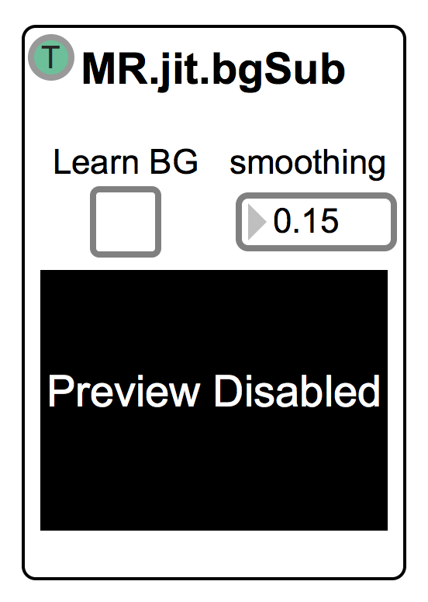
bgSubMatrixIn: [matrix] matrix from movie or camera feed (see input 1)

bgSubInput: [int; toggle] 0 = “through”
1 = “luma”

bgSubPreview: [int, sym; toggle] 0 or Off/off disables the preview window
1 or On/on enables the preview window

bgSubLearn: [int; toggle] 0 turn background learning Off
1 turn background learning On

bgSubLearnL [int] turns the background learning On. The supplied integer
is the time in ms after which learning is turned Off (def
1000ms)

bgSubSmoothing: [float; 0- 1] set the smoothing amount

Output:
bgSubMatrixOut: [matrix] resulting matrix (see output 1)

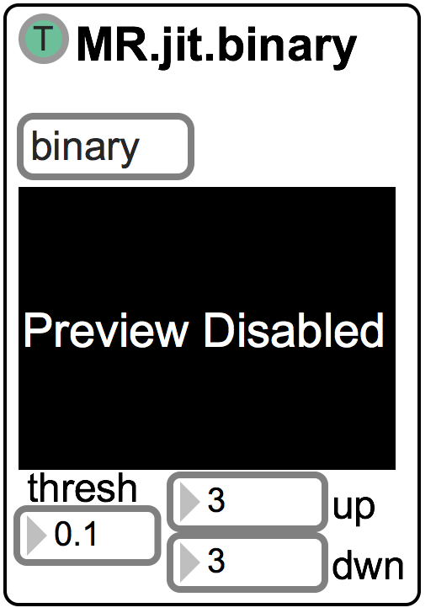
MR.jit.binary

Perform a simple binary-threshold conversion with optional frame smoothing. Compare each pixel of an incoming frame to the threshold and if it is equal or above the threshold, set the pixel to maximum (i.e. white) otherwise minimum (i.e. black).

Result: There are two options for creating the binary image.

1) binary: a simple threshold operator comparing each pixel to the threshold and setting it accordingly.

2) adaptive: Uneven illumination is often a problem when thresholding an image. Adaptive thresholding addresses this issue by adjusting the threshold based on the brightness of an area surrounding each pixel. The difference between the pixel value and the average brightness of pixels within the distance set by the "radius" attribute is calculated. If it is greater than the "threshold" value, the pixel value is set to ON.
If the "mode" attribute is set to 1, the calculation is reversed – in order to select dark regions instead (JMP – cv.jit.threshold helpfile).

Inputs (1): matrix to be manipulated (argb or gray scale for “binary”, gray scale ONLY for “adaptive”)

Outputs (2): 1) resulting matrix (argb or gray scale, depending on input)
2) number of on-pixels for the entire, current frame. Single number
if gray scale input, otherwise list of numbers with one for each
plane in the matrix.

Remote messages:

binaryMatrixIn: [matrix] matrix from movie or camera feed (see input 1)

binaryInput: [int; toggle] 0 = “through”
1 = “luma”

binaryPreview: [int, sym; toggle] 0 or Off/off disables the preview window
1 or On/on enables the preview window

binaryMode: [int; toggle] 0 turn “binary” mode On
1 turn “adaptive” mode On

binaryThresh: [float] set the threshold for the pixel comparison. This value sets both the “binary” AND the “adaptive” thresholds.

binaryAdaptMode: [int; toggle] 0 = turn adaptive mode to 0 (default; select light regions)
1 = turn adaptive mode to 1 (select dark regions)

binaryAdaptRadius: [int] radius in pixels for which to calculate the average brightness

binaryDown: [float] set the smoothing factor

binaryUp: [float] set the smoothing factor

Output:
binaryMatrixOut: [matrix] resulting matrix (see output 1)

binaryCountOut: [float/list] output the current frame’s active pixel count (see
outputs 2).

MR.jit.blob

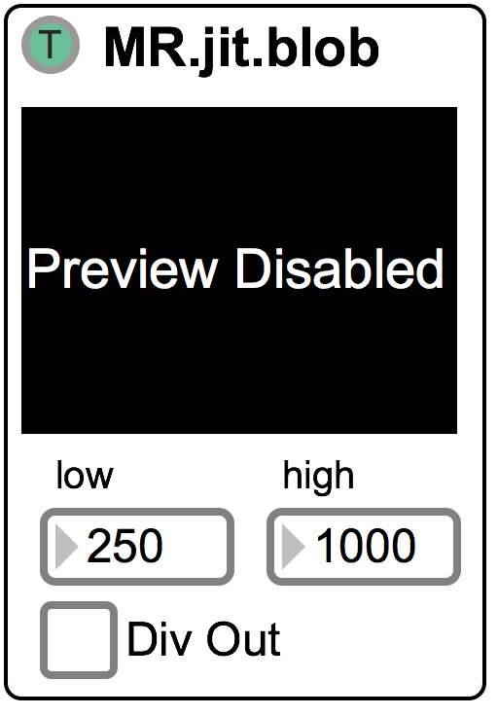
Here we perform simple blob detection on a binary image. Each connected component is considered a blob. Some work needs to be done in order for this module to function properly. See the helpfile for an example of how an incoming video stream could be manipulated to achieve higher success rates.

Result: Compute blobs, label them in the preview window and output their locations.

Inputs (1): matrix to be manipulated (gray scale)

Outputs (2): 1) cooked stream of blob coordinates
2) raw stream of blob coordinates

Remote messages:

blobMatrixIn: [matrix] matrix from movie or camera feed (see input 1)

blobInput: [int; toggle] 0 = “through”
1 = “luma”

blobPreview: [int, sym; toggle] 0 or Off/off disables the preview window
1 or On/on enables the preview window

blobLow: [int] low threshold of blob size (in pixels); blobs below will be ignored

blobHight: [int] high threshold of blob size (in pixels); blobs above will be ignored

blobOutDiv: [int; toggle] 0 = turn blob division Off; blobs are output
successively and not delineated even between
frames
1 = turn blob division On; delineate blob output
with a “-1” after all blobs in the frame are
output

Output:
blobCookedOut: [list] list of bounding rect of found blobs; only output blobs that are within the min and max thresholds

blobRawOut: [list] list of all bounding rect of found blobs

MR.jit.bounds

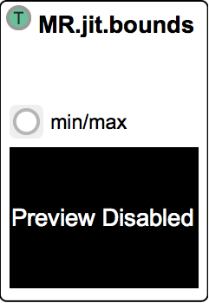
This abstraction looks for the bounding region of a specified colour. The colour needs to be set in the min/max abstraction. Here an ARGB list is necessary for the max colour value to search for as well as a minimum colour value. When “Preview Colour ON” is selected (and the preview window is currently enabled) a click of the mouse will set the colour of the selected pixel to be the min/max values, -/+ 10% of the selected value.
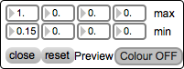

Result: outputs a list of coordinates for the minimum and maximum extremes of the found colour regions.

Inputs (1): matrix to be manipulated

Outputs (3):
- normalized bounding rect (0. - 1.)
- raw bounding rect (in matrix dimension)
- original matrix with bounding rect overlay

Remote messages:

boundsMatrixIn: [matrix] matrix from movie or camera feed (see input 1)

boundsInput: [int; toggle] 0 = “through”
1 = “luma”

boundsPreview: [int, sym; toggle] 0 or Off/off disables the preview window
1 or On/on enables the preview window

boundsOpen: [bang] opens the Min/Max colour chooser abstraction

boundsClose: [bang] closes the colour chooser abstraction

boundsMinMax: [list] a list of ARGB values. The min/max regions will be set with a 10% padding on either side.
boundsMin: [list] ARGB values for the minimum colour range

boundsMax: [list] ARGB values for the maximum colour range

boundsReset: [bang] reset colour range to default settings

boundsPreviewColour: [int; toggle] trigger the Preview window to be used as a colour picker

Output:
boundsScaledOut: [list] list of normalized (0. – 1.) bounding rect coordinates

boundsRawOut: [list] list of matrix sized bounding rect coordinates

boundsMatrixOut: [matrix] original matrix with bounding rect overlay

MR.jit.boundsComplex

Convenience bpatcher that combines the functionalities of the MR.jit.motionComplex and MR.jit.bounds. See those objects for more detailed explanations.

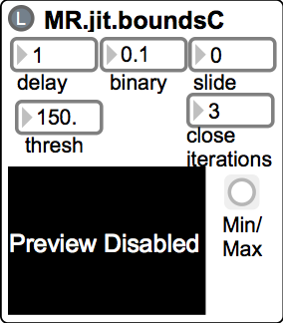
Remote messages:

The messages for boundsComplex should be the same as for its constituent parts. However, “boundsC” is prepended to any message instead of “bounds” (in the case of MR.jit.bounds messages) and “motionC” (in the case of MR.jit.motionComplex).

This is object is still under development! Some messages and functionality might not be implemented yet! Contact me if you would like to have a feature included.

MR.jit.center

Simply calculates the center of a given region of on pixels (see helpfile for example).

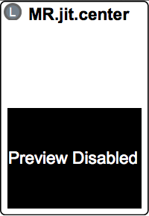
Result: outputs the x/y location of the current centroid (in matrix dimensions)

Inputs (1): matrix to be analyzed

Outputs (2):
- x/y location of centroid in matrix dimensions
- original matrix out with centroid location overlay

Remote messages:

centerMatrixIn: [matrix] matrix from movie or camera feed (see input 1)

centerInput: [int; toggle] 0 = “through”
1 = “luma”

centerPreview: [int, sym; toggle] 0 or Off/off disables the preview window
1 or On/on enables the preview window

Output:
centerOut: [list] list of x/y coordinates in matrix dimensions

boundsMatrixOut: [matrix] original matrix with center overlay

MR.jit.close

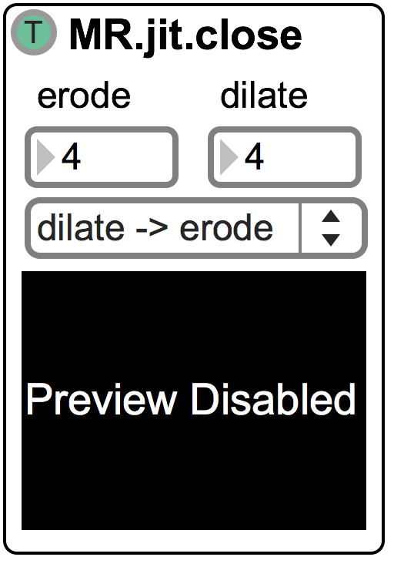
Apply up to 6 successive dilate operations (remove off-pixel noise) and 6 successive erode operations (restore shape to similar area). Dilate and erode operations are taking either the local maximum or local minimum of a kernel and set the kernel’s anchor point to that value. Performing both a dilate and erode operation in succession is called a “close” operation and reduces noise-driven segments. The “open” operation consists of performing an erode followed by a dilate operation and has a tendency to separate regions.

Result: The dilate operation will increase the overall size of on-pixel regions and potentially join several closely situated areas and smooth out concave areas. The erode operations however will minimize and separate on pixel regions and also smooth out convex areas.

Inputs (1): matrix to be manipulated (argb or gray scale)

Outputs (1): resulting matrix (argb or gray scale, depending on input)

Remote messages:

closeMatrixIn: [matrix] matrix from movie or camera feed (see input 1)

closeInput: [int; toggle] 0 = “through”
1 = “luma”

closePreview: [int, sym; toggle] 0 or Off/off disables the preview window
1 or On/on enables the preview window

closeMode: [int; toggle] 0 enables the “close” method (dilate -> erode)
1 enables the “open” method (erode -> dilate)

closeErode: [int] An integer from 1 – 6 sets how many erode operation
are performed in succession

closeDilate: [int] An integer from 1 – 6 sets how many dilate operation
are performed in succession

Output:
closeMatrixOut: [matrix] resulting matrix (see output 1)

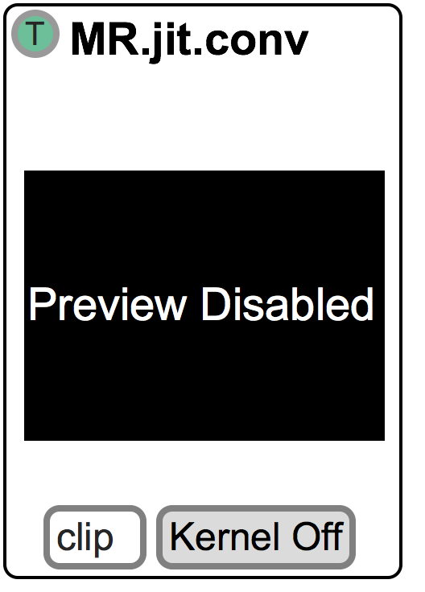
MR.jit.conv

Apply simple convolution to an image with a 3x3 customizable kernel.

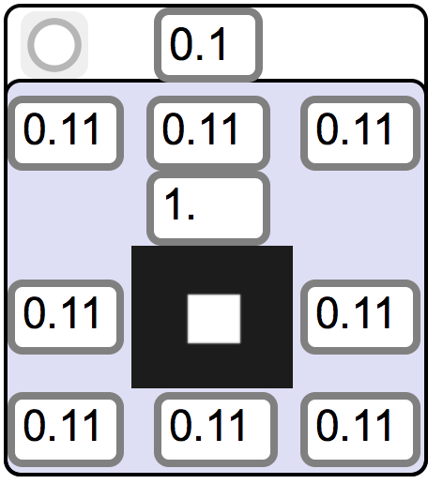
The kernel can be customized manually or by remote messaging. Values are between 0 (off) and 1 (on).

Result: The kernel convolutes the incoming matrix. This is useful for blurring, sharpening and edge detection.

Inputs (1): matrix to be manipulated (argb or gray scale)

Outputs (1): resulting matrix (argb or gray scale, depending on input)

Remote messages:

convMatrixIn: [matrix] matrix from movie or camera feed (see input 1)

convInput: [int; toggle] 0 = “through”
1 = “luma”

convPreview: [int, sym; toggle] 0 or Off/off disables the preview window
1 or On/on enables the preview window

convMode: [int;symbol] Determines how points outside the input matrix
are handled. Send either the integer or the mode
name.
0 = clip
1 = wrap
2 = ignore

convKernel: [int; toggle] Turn display for adjusting the convolution kernel
On or Off

convKernelReset: [bang] reset the kernel to the default settings: 1.0 at the center
and 0.11 everywhere else

convKernelSet: [float] set all cells to this number

convKernelSetM: [list] a list of nine elements will set the nine cells of the
convolution kernel

Output:
convMatrixOut: [matrix] resulting matrix (see output 1)

MR.jit.delay

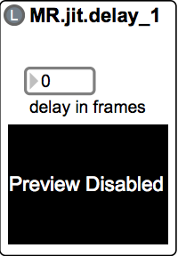
Delay an incoming stream of matrices by a certain amount (in frames).

Inputs (1): matrix to be manipulated

Outputs (2): delayed matrix

Remote messages:

delayMatrixIn: [matrix] matrix from movie or camera feed (see input 1)

delayInput: [int; toggle] 0 = “through”
1 = “luma”

delayPreview: [int, sym; toggle] 0 or Off/off disables the preview window
1 or On/on enables the preview window

delayFrames: [int] amount of frames the incoming video is delayed (if <= 2, video plays through)

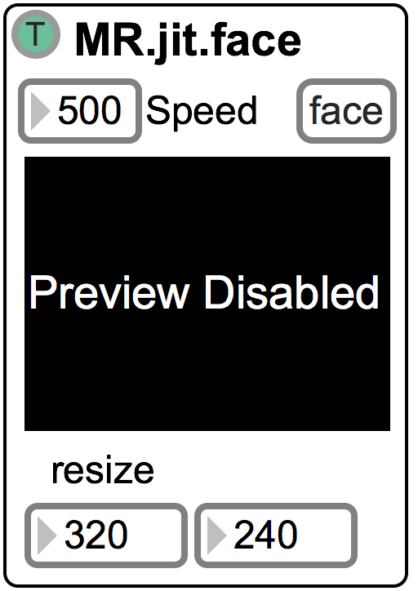
MR.jit.face

This module will try and find a face in the incoming matrix. This is extremely computationally expensive and great care should be given about when and how this module is used! The “Speed” attribute reduces the incoming frame rate to the set amount in msec. By default this will output a new frame every 500 msec and drop everything else in between.
To further reduce computation, the incoming matrix size can be scaled down. A matrix size as small as 160x120 should work fine for most applications. The default is 320x240.

There are two modes in which this module can operate:
- face
- trackIt

1) In this mode, the matrix is analyzed according to the “Speed” setting as explained above. If a bang is sent to the right inlet or the “faceFind” message is used, the module will bypass the “Speed” attribute and look for a face in each incoming frame until a face is found. When a face is found the “Speed” attribute is reengaged.

2) TrackIt mode behaves very much like “faceFind” in that each incoming frame is analyzed for a face. Once a face is found the tracking is turned OFF until a bang is sent in the right inlet or the “faceFind” message is used again. This is useful for combining MR.jit.face with other tracking methods such as MR.jit.trackIt (hence the name). See MR.jit.faceOpt to see an example of this feature.

Result: Identify faces in an incoming matrix and output their bounding rectangles.

Inputs (2): 1) matrix to be searched (gray scale)
2) bang, look for a face now (for use with “trackIt” mode)

Outputs (2): 1) list of face coordinates
2) output original matrix with superimposed bounding rectangle

Remote messages:

faceMatrixIn: [matrix] matrix from movie or camera feed (see input 1)

faceInput: [int; toggle] 0 = “through”
1 = “luma”

facePreview: [int, sym; toggle] 0 or Off/off disables the preview window
1 or On/on enables the preview window

faceSpeed: [int] set the interval in msec for which frames are output to be
analyzed

faceMode: [int; symbol] switch between the two analysis modes. Use
integers (0, 1) or the corresponding symbols to
toggle:
0 = face
1 = trackIt

faceResize: [list] send two integers to set the resize dimensions

faceResizeW: [int] set the width of the resize matrix individually

faceResizeH: [int] set the height of the resize matrix individually

faceFind: [bang] find a face NOW. This will bypass the “Speed” attribute
(if in “face” mode) and each incoming frame will be
analyzed until a face is found. After a face is found the
module is reset to the previous state (either “face” or
“faceIt”)

Output:
faceCoordOut: [list] coordinates for the bounding boxes of the face

faceMatrixOut: [matrix] output original matrix with superimposed bounding
rectangle (see output 2)

MR.jit.faceOpt

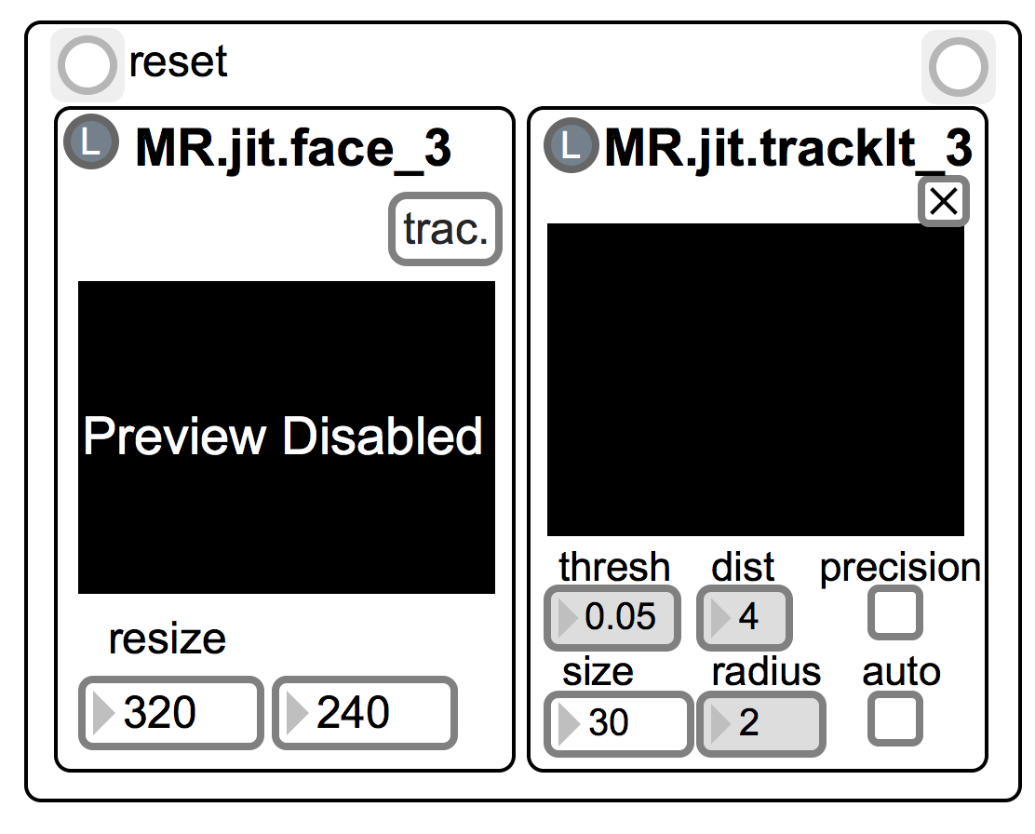
This module combines the MR.jit.face and MR.jit.trackIt modules to create a more robust and less CPU intensive face tracking solution. Here MR.jit.face is set to “trackIt” mode (see info above) and MR.jit.trackIt will cause the face tracking to be updated if need be. If MR.jit.trackIt thinks it is lost the update information is sent to MR.jit.face and it looks for a face until one is found. This module was designed with the intent of tracking ONE face only. If more then one face is in the frame the behaviour is undefined!!

Result: Look for face in incoming frame. Output the mean position of all tracking points.

Inputs (2): 1) matrix to be searched (gray scale)
2) bang, reset module to default settings

Outputs (4): 1) mean position of all tracking points
2) positions of all tracking points
3) matrix with tracking points superimposed
4) face bounding rectangle

Remote messages:

faceOptMatrixIn: [matrix] matrix from movie or camera feed (see input 1)

faceOptInput: [int; toggle] 0 = “through”
1 = “luma”

faceOptPreview: [int, sym; toggle] 0 or Off/off disables the preview
window

faceOptReset: [bang] reset module to default values

Output:

faceOptMeanTP: [list] output mean tracking point (see output 1)

faceOptRawTP: [list] output position of all tracking points (see output 2)

faceOptMatrixOut: [matrix] matrix with tracking points superimposed (see
output 3)

faceOptFaceCoord: [list] get face bounding rectangle (see output 4)

All messages for MR.jit.faces and MR.jit.trackIt are also valid!! See their documentation for more info.

MR.jit.keying

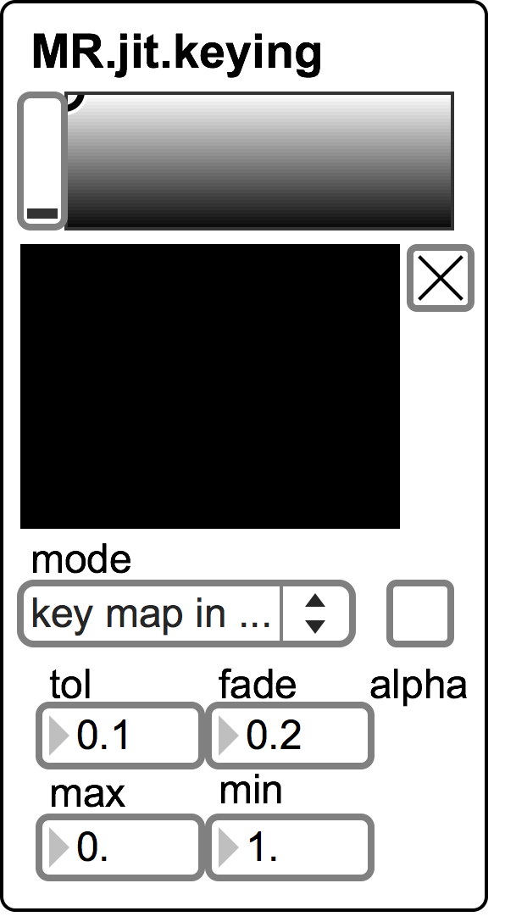
This bpatcher creates a chromakey effect based on a reference color. Click the preview image to select the color or send a message with the color information. Tolerance, fade, min, and max values change. A matrix in the second inlet will replaced the "keyed" areas. The toggle to the right of the preview window enables/disables it.

Result: Output a chroma keyed matrix.

Inputs (2): 1) matrix to be chroma keyed
2) matrix to replace the keyed regions
(depending on mode settings)

Outputs (1): the chroma keyed matrix

Remote messages:

keyingMatrixIn: [matrix] matrix from movie or camera feed (see input 1)

keyingMatrixIn2: [matrix] matrix from movie or camera feed (see input 2)

keyingPreview: [int, sym; toggle] 0 or Off/off disables the preview
window

keyingSaturation: [int] set the saturation level (0 – 255)

keyingColor: [list] rgb values 0. – 1.

keyingAlpha: [int; toggle] 0 ignore alpha channel
1 use alpha channel

keyingTol: [float] The range of variance from a cell’s absolute value
when calculating keying (0. – 1.)

keyingFade: [float] fade amount (0. – 1.)

keyingMax: [float] max keying value (default 1.)

keyingMin: [float] min keying value (default 0.)

keyingMode: [int] matrix output mode:
0 = perform keying and output matrix
1 = output the key map for use elsewhere
2 = alpha contains key map, other planes are from
left input

Output:

keyingMatrixOut: [matrix] output resulting matrix (see output 1)

MR.jit.matrixSize

MR.jit.matrixSize is an abstraction rather than a bpatcher that reports the size of an incoming matrix and sends it out prepending a string given as an argument…

MR.jit.motionComplex

This is a convenience bpatcher that combines several other analysis modules to quickly analyze motion…
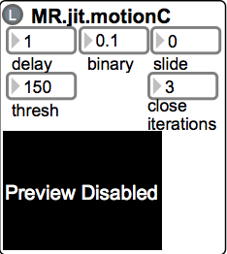

More info coming soon… (see helpfile for now)

MR.jit.subMatrix

Resize the incoming matrix to new dimensions.

Toggle: certain cv.jit.objects need to have a matrix size that is a multiple of 4. Toggle ON to force the bpatcher to calculate to appropriate dimensions…

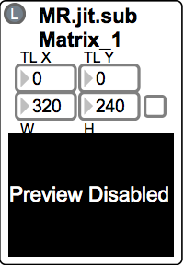

More info coming soon…

MR.jit.videoRec

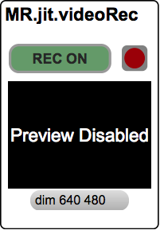
Record video and audio into separate files (audio only if MR.jit.videoAudioRecBP is used).

More info coming soon (see helpfile for now…)

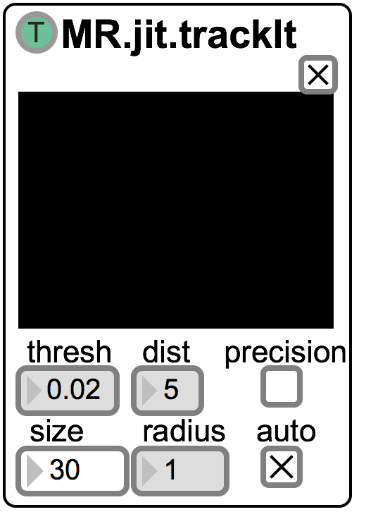
MR.jit.trackIt

This module analyses a region for trackable features and then tries to follow them. If the features get lost, the area is spawned again with the last mean position of the tracking points (the red square). Clicking in the preview window will set the initial tracking region (can also be set via message or right inlet). The toggle to the top-right of the preview window will enable/disable the preview window.

Result: Track and output the position of found features. Restart the tracking if features get lost.

Inputs (2): 1) matrix to be analyzed (gray scale)
2) rectangular area in which to look for
features

Outputs (4): 1) mean position of all tracking points (red
square in preview window)
2) all tracking points
3) input matrix with tracking points
superimposed
4) bang when tracking points got lost and
the module is resetting itself; This bang
will ALWAYS be sent, even if the module
is NOT in “auto” mode

Remote messages:

trackItMatrixIn: [matrix] matrix from movie or camera feed (see input 1)

trackItInput: [int; toggle] 0 = “through”
1 = “luma”

trackItPreview: [int, sym; toggle] 0 or Off/off disables the preview
window

trackItThresh: [float] determines the amount and robustness of features (0. –
1.). Lower values return more, but weaker features.

trackItDistance: [int] minimum distance in pixels between features

trackItPrecision: [int; toggle] turn subpixel accuracy on or off. High impact on
CPU if turned on.

trackItRawDimGet: [list] dimension of original, incoming matrix

trackItReset: [bang] reset the tracking region to the last valid mean-point
position

trackItAuto: [int; toggle] turn auto retrigger On/Off (default On). When on,
the module will try and find good features based
on the last mean-point position when the tracker
gets lost.

trackItRadius: [int] size of the search window for each tracked point

trackItSize: [int] size (width, height) of the rectangular area in which to
look for features when clicking the preview window,
sending the “trackItPoint” message or using “auto” mode.

trackItPoint: [list] x/y coordinate for the center of the tracking area. The
“trackItSize” message calculates the size of the rectangle
from this point.
trackItRoi: [list] Region of interest (Roi). Send a list with rectangular
coordinates (TL, BR) to set the tracking region

Output:

trackItRawDim: [list] dimension of original, incoming matrix

trackItMeanTP: [list] output mean tracking point (see output 1)

trackItRawTP: [list] output position of all tracking points (see output 2)

trackItMatrixOut: [matrix] matrix with tracking points superimposed (see
output 3)

trackItInternalReset: [bang] send bang when tracker is reset (sent regardless of
“auto” mode; see output 4)

Instrument Tracking:

Currently there are two complex modules that were created for tracking instrumentalists. One is for piano tracking, the other trombone tracking. These are still in development and might change frequently…

Piano Tracking

This bpatcher was created for Dr. Keith Hamel and his piano and interactive electronics piece “Touch” for Corey Hamm. It is in desperate need of some TLC! More info and instructions once it has received some…

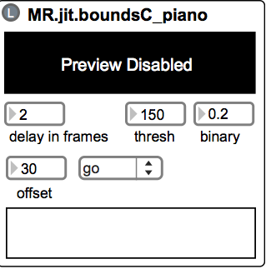

Trombone Tracking

This bpatcher is still under construction and testing. It was also created for Dr. Keith Hamel for his upcoming piece for trombone and interactive electronics for Jeremy Berkman.

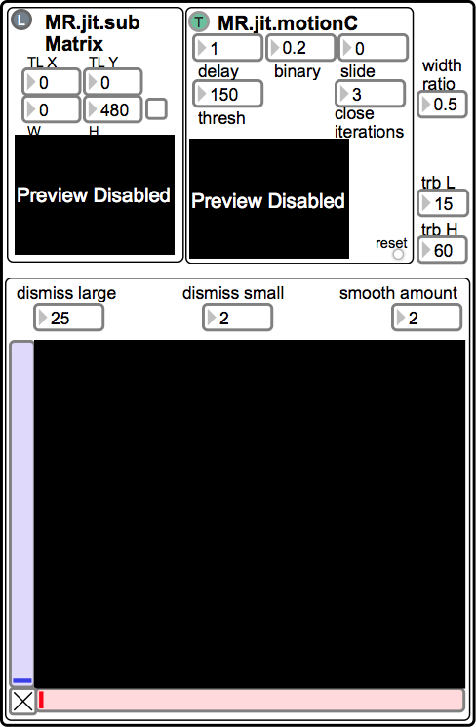

Upcoming Modules:

MR.jit.camShift

A module using the camShift algorithm to track regions of interest. This has been successfully tested in a piano tracking situation. A simplified version is in the works…

MR.jit.flow
A module that analyses the overall motion/flow of the incoming matrix stream…

